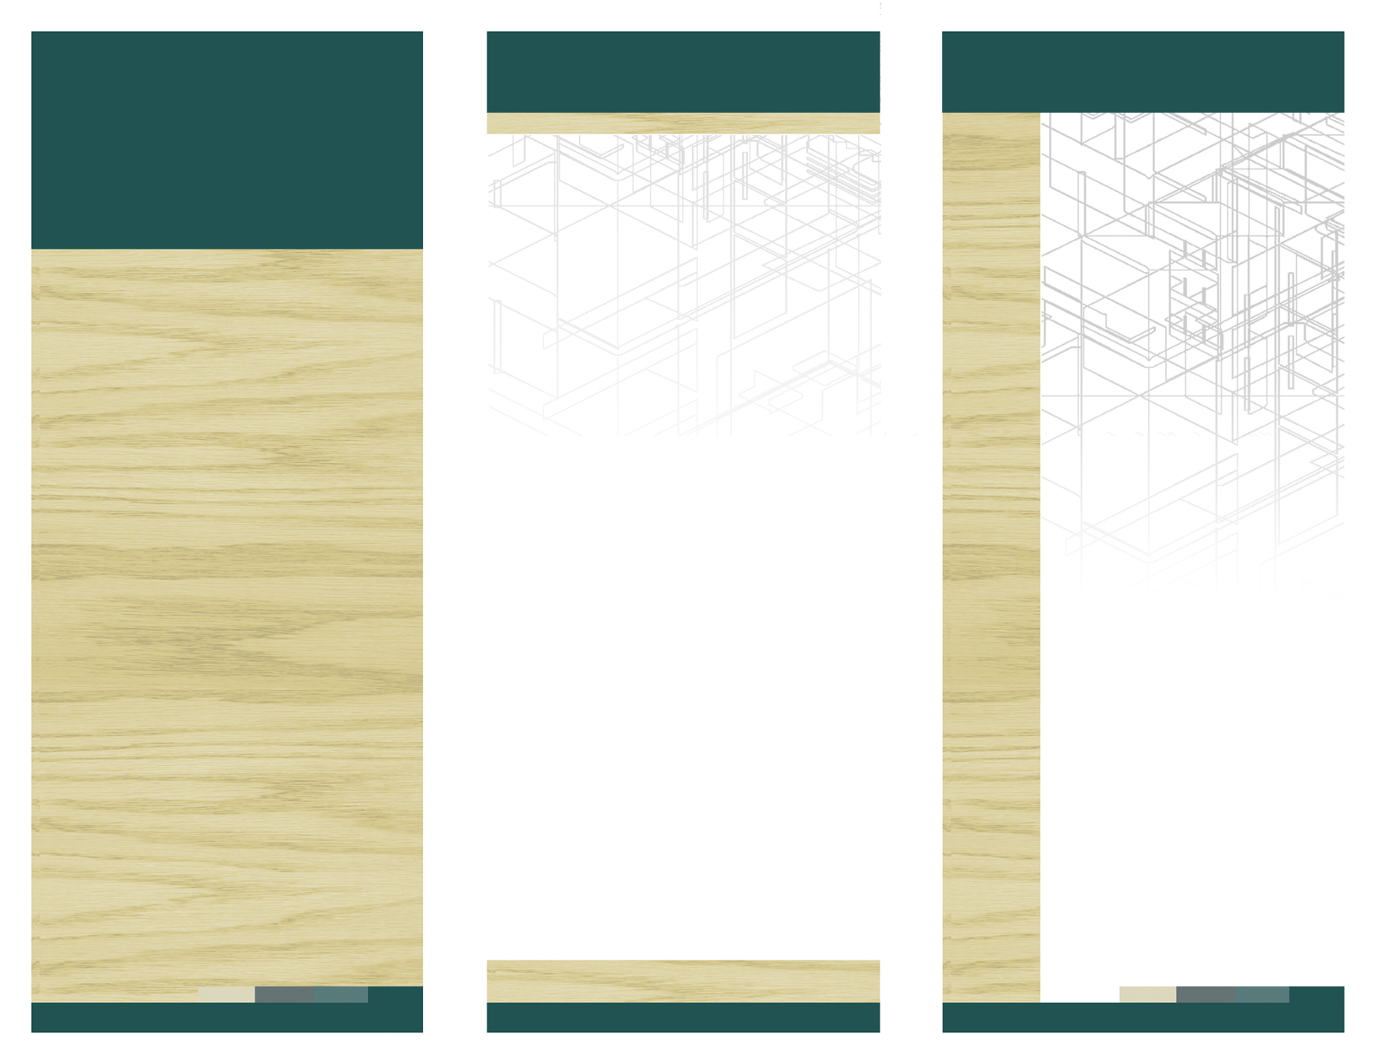


SOBER LIVING HOMES ASSOCIATION

S.A.F.E. HOUSE – City Heights

SAFE HOUSE Sober Living Home is part of a group of homes we operate including Beachwalk Sober Living Home in Oceanside & CLAIREMONT WOMEN’S SOBER LIVING HOME in San Diego.

We have been operating since 1996 providing quality living facilities for people who are serious in their efforts to lead a clean and sober life. We are committed to helping you in you reach that objective.

We are also a proud member of the Sober Living Homes Association of San Diego and the Sober Living Network of Southern California.

For additional information, visit us at:
www.soberlivingsd.com

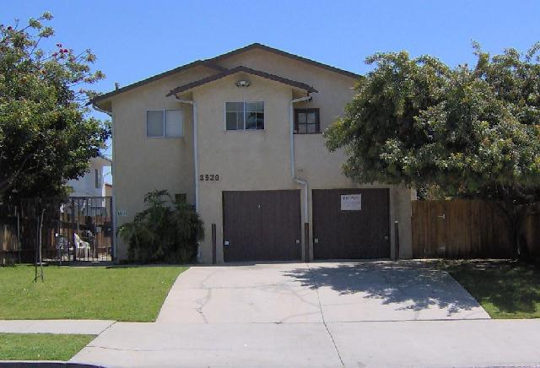
3529 Van Dyke Avenue,
San Diego, CA 92105

Tel. (858) 483-5866 x 4
Fax: (858) 483-5866
eMail: soberlivingsd@yahoo.com

DELETE BOX, OR PLACE TEXT OR LOGO HERE
Ph 555.555.5555 Fx 555.555.5555
5555 Street Address City, US, 55555

www.webaddress.com
Delete box or place a tag line or quote here. Delete box or place a tag line or quote here. Delete box or place a tag line or quote here. Delete box or place a tag line or quote here.

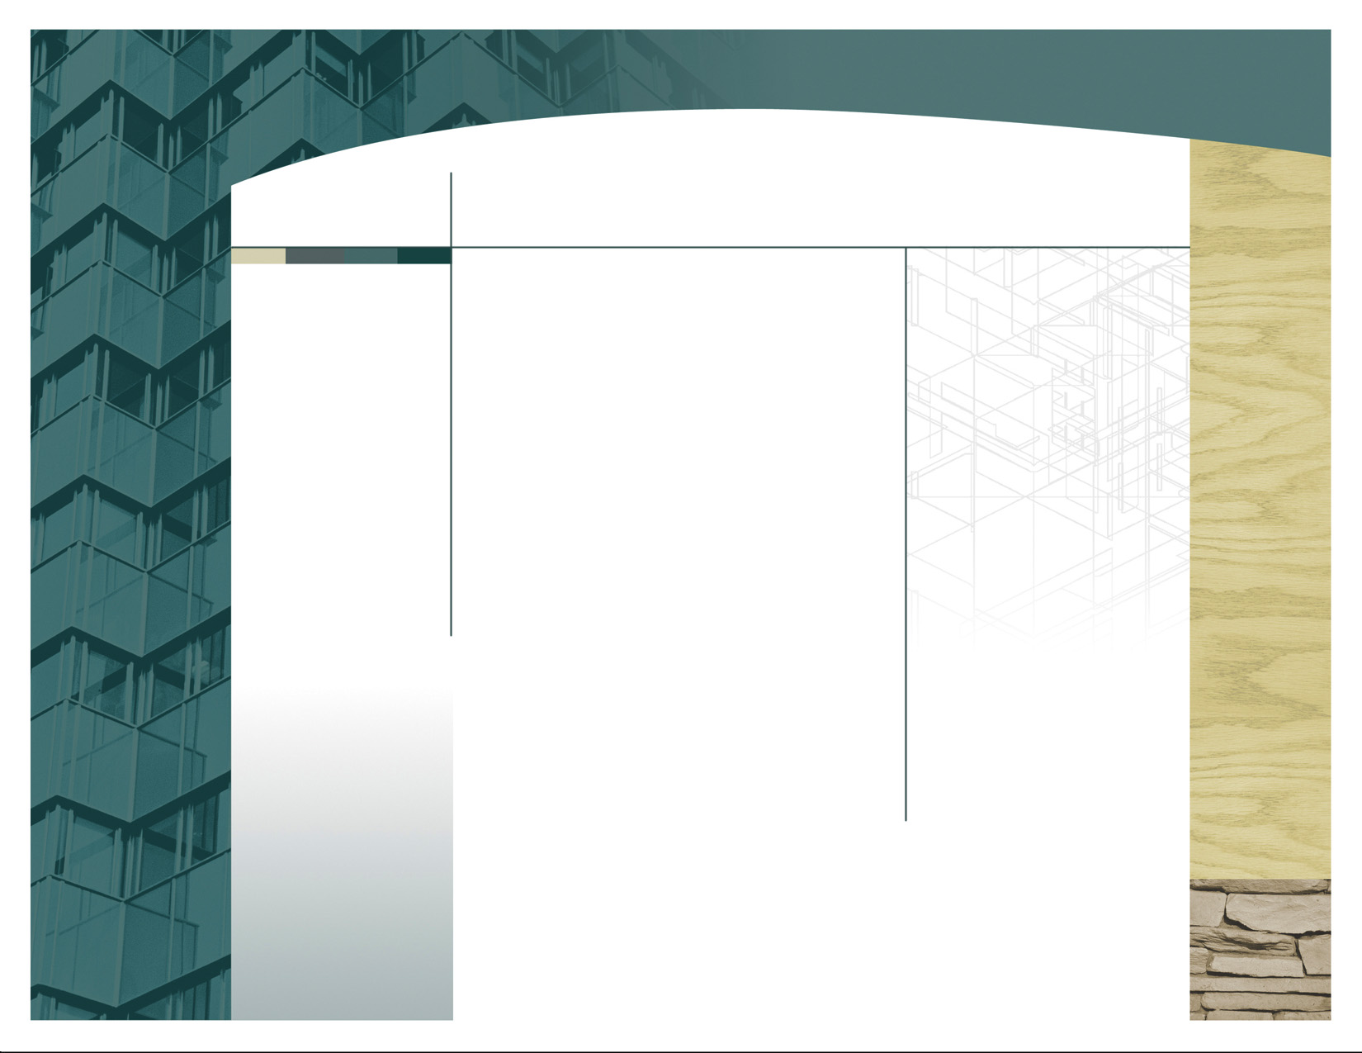
We provide the following:
- Furnished units
- On-site coin laundry
- Access to public transportation
- Garages (when available)
- Free community telephone
- Patio for units on ground level

S.A.F.E.
House
means
Sober
And
Friendly
Environment

SAFE HOUSE

CITY HEIGHTS
City Heights is centrally located with easy access to major freeways, convenient public transportation and shopping and entertainment.
We are also close to schools making it ideal and safe for children.
Contact Us
Tel. (858) 483-5866 x 4
eMail: soberlivingsd@yahoo.com



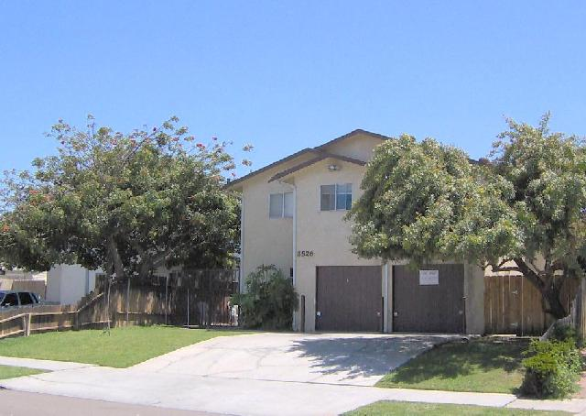

SAFE HOUSE was established in 1996. A gated community consists of five unit townhouses located in the revitalized City Heights area of San Diego.
As with other sober living homes, weekly group meetings and zero tolerance policies are strictly enforced. Group outings and other activities are encouraged since we provide accommodations for men, women, couples and parents with children.
A resident manager on the premises can also help with emergency situations and assist with your other needs.

Delete box or place a tag line or quote here. Delete box or place a tag line or quote here. Delete box or place a tag line or quote here. Delete box or place a tag line or quote here.

